

**Monday 25 November 2019**

AN-NAJAH NATIONAL UNIVERSITY

DEPARTMENT OF MEDICINE

Pediatrics Senior ILOs

(7223601)

# Course Outline

* **Course Details**

|  |  |
| --- | --- |
| Course Title | Pediatrics Senior |
| Course Number | 7223601 |
| Prerequisite(s) | Finish 5th year |
| Course Type: | Compulsory |
| Credit Hours | 8 |

* **Class Details**

|  |  |
| --- | --- |
| Weeks | 8weeks |
| Time | 5 days/ week 8:00 am- 2:00 pm. |
| Location | An-Najah National University Hospital and Ministry of Health Hospitals affiliated to An-Najah National University in the northern of West Bank |

* **Course Description and Objectives**

|  |
| --- |
| This is an eight-week rotation for sixth year medical students based of the knowledge taken during the fifth year. During this 8-week rotation, students are exposed to different settings through rotating with different sub specialist in different hospitals. This includes both in patients and out patients encounters. This rotation is to emphasize active student's involvement of students in patient care and allow them to follow their own patients with continuity. Students are also encouraged to act at the level of interns in preparation for graduation requirement. Throughout the course, students will be involved in the daily morning report, clinical rounds, outpatient clinics and interactive seminars. |

# Textbooks and References

|  |
| --- |
| Textbooks |
| 1. **Nelson Essentials of Pediatrics**  8th Edition  by Karen Marcdante, Robert Kliegman.  2. **BRS Pediatrics (Board Review Series) 2nd Edition**  by  Lloyd J. Brown, Lee Todd Miller |
| References |
| * **Nelson Textbook of Pediatrics**, 2-Volume Set, 21st Edition, Authors: Robert Kliegman Joseph St. Geme |

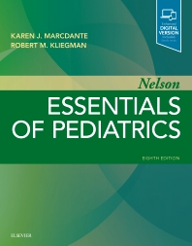

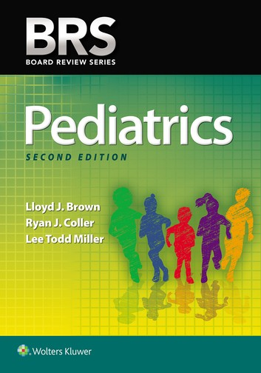

# Topics and teaching methods

|  |  |
| --- | --- |
|  | **Topics were covered during the course** |
| 1 | Approach to a child with hypotonia |
| 2 | Approach to a child with loss of consciousness |
| 3 | Approach to a child with Rickets calcium disorder |
| 4 | Approach to a child with Anemia |
| 5 | Approach to a child with lymphadenopathy or hepatosplenomegaly |
|  |  |
| 6 | Approach to a child with acute and/ or chronic diarrhea |
| 7 | Formula versus breast feeding. |
| 8 | Approach to a child with seizure and fever/ status epilepticus |
| 9 | Approach to a child with FTT |
| 10 | Approach to a child with heart murmur or CHF |
|  |  |
| 11 | Approach to newborn with hyperbilirubinemia |
| 12 | Approach to new-born with cyanosis (cardiac). |
| 13 | CPR & Emergency / ABG interpretation |
| 14 | Antibiotic therapy in common pediatric infections |
| 15 | Fluid Therapy/ hypovolemic shock/ ARF |
|  |  |
| 16 | Approach to new-born with respiratory distress |
| 17 | Approach to a child with Developmental delay |
| 18 | Approach to a child with wheezy chest |
| 19 | Approach to fever without focus in infants with different ages. |
| 20 | Approach to a child with excessive bleeding tendency |
|  |  |
| 21 | Neonatal resuscitation |
| 22 | Approach to a child with Red Urine and/or proteinuria |
| 23 | Approach to a child with short stature/ thyroid disorders |
| 24 | Antibiotic therapy in special disease |
| 25 | (CF. Neutropenia immunodeficiency, abscess, osteomyelitis ) |
| 26 | Chromosomal disorders |
| 27 | Case-Based Teaching |

# Updates and Advances in Pediatrics:

Students are involved in all of the hospital’s teaching activities including attending morning reports, Journal Clubs, lectures, seminars and Rounds. Updates on guidelines, Case study discussions and other advances in Pediatrics are usually a part of the Morning report, Journal Clubs and Mid-day activities. Students are involved in carrying out presentations in selected topics and cases nominated by their teaching physicians.

# Integration with Health system and Community

In addition to the curriculum above, a valued focus on the most common diseases and topics in the Palestinian community is given which includes immunization, primary health care including developmental monitoring, nutrition and others. This is more obvious in morning reports, journal clubs and mid-day activities. Students are also encouraged to do medical days that takes a picture of screening campaigns in the local Palestinian community that includes developmental milestones screening, undescended testicles examination, ophthalmic and ear examinations.

* **Topics Covered in Clerkships:**

|  |  |
| --- | --- |
| **Week** | **Topics** |
| 1 | History taking and Physical Examination  Cardiovascular system |
| 2 | Respiratory system  Gastrointestinal system |
| 3 | Neonatology  Nephrology |
| 4 | Musculoskeletal system  Rheumatology |
| 5 | Hematology  Endocrinology system |
| 6 | Neurology  Oncology |
| Note: | * Not all Students have the same order of the weeks’ topics. This is a rough distribution of the topics to weeks, sometimes some topics takes more than one week, others take less. Moreover, it also depends on the attending physician specialty. By the end of the clerkship every student should cover all the above mentioned topics. |

# Assessment

|  |  |  |
| --- | --- | --- |
| **Exam Format** | **Note** | **Weight (%)** |
| OSCE-exam | Practical exams done at the end of the academic year to evaluate the medical knowledge of students, ability to take medical history and clinical skills. It includes 5 stations each of 7 minutes’ duration. 1 of these stations is dry in which students answer cases-questions based on their knowledge in data interpretation and management. | 40% |
| Written exam | An exam done at the end of the academic year to evaluate the medical knowledge. Moreover, these exams are provided from the National Board of Medical Examiners (NBME) in USA which is an independent, not-for-profit organization that serves the public through its high- quality assessments of healthcare professionals. | 40% |
| Evaluation | Evaluation during rotation which depends on: daily attendance of morning report, educational rounds, clinical skills, basic medical procedures, group discussions, seminars, lectures attendance, student attitude and respect for patients and team. | 20% |
| Total |  | 100% |

# Student Evaluation Form During Clerkships

# Important Dates

|  |
| --- |
| * **At the end of the Academic year: OSCE Exam and written Exam** |

# Teaching and Learning Methods

|  |
| --- |
| **Tools** |
| 1. Lectures. 2. Small-group teaching. 3. Problem-based or case-based learning. 4. Peer assisted learning. 5. Bed-side teaching. 6. Clinical demonstrations. 7. Field exercises in the community. |

# Course **Policies**

* Students should attend all the activities mentioned above during this clerkship every day, and do the required on-calls.
* The maximum allowed absence is 10% of the clerkship’s duration and this only in case of an accepted situation evaluated by the Department of Medicine.
* Students are not allowed to have even a single day off without an accepted reason evaluated by the department of medicine. In that case, 2 points of the clerkship total will be subtracted and this will be added to the student file record.